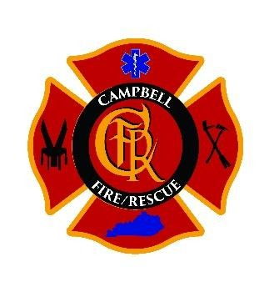

Sponsored by the

Campbell Fire/Rescue

and NKYTRT

**October 6th – October 10th 2025**

8:30

to 17:00

Daily



Rope

Rescue Technician Class

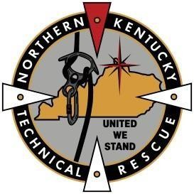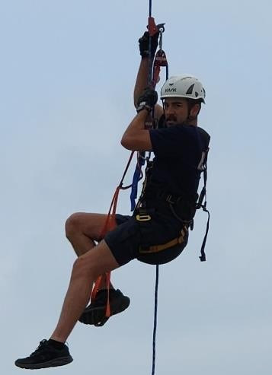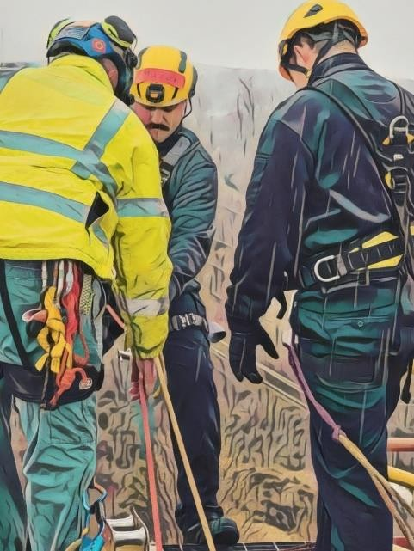

Hands-on sessions will be at different sites throughout Northern KY with Day 1 being at the Campbell Fire / Rescue Station 1, HQ – 7951 Alexandria Pike. Alexandria, KY 41001

This 40-hour high intensity course is designed to expand the student’s working knowledge of rope rescue. Classes will be extensively hands-on, covering techniques to meet and exceed the requirements of NFPA 1670(2017) and NFPA 1006(2021).

Student Pre-Requisites: Firefighter or Rescuer with appropriate agency sponsorship to include Insurance.

Students will need the following items (compliant to NFPA 1983 and inspected day 1):

1) Rope Rescue Harness

1. Helmet
2. Clean gloves suitable for rope work
3. Appropriate dress for the weather, including long pants
4. Boots with good tread and ankle support

Class Cost: $80.00 to cover costs associated with the class. Please Submit payments to:

Campbell Fire/Rescue

C/O: Rope Rescue

7951 Alexandria Pike

Alexandria, KY 41001

To register see link at [www.cfrky.org](http://www.cfrky.org/)

or Contact Assistant Chief Adam Bradbury at (859)635-5991 or abradbury@cfrky.org